**Homework 7: Windows Admin and Hardening**

**Task #1:** Create a GPO: Disable Local Link Multicast Name Resolution (LLMNR)

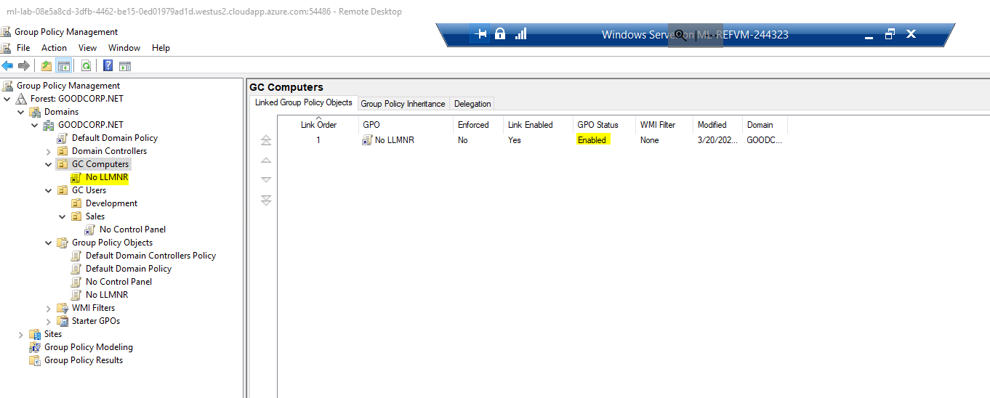

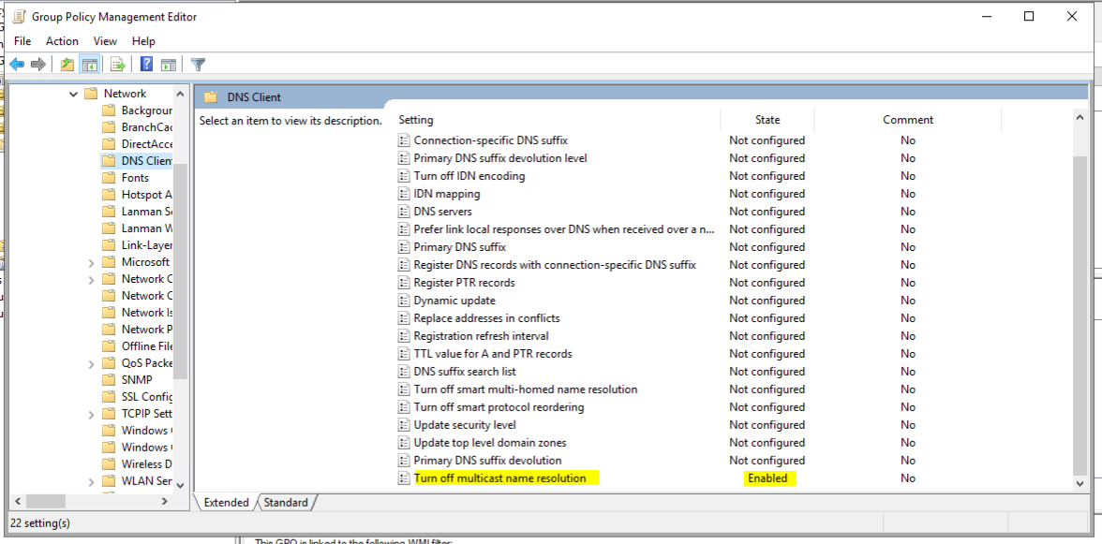

**Task #2:** Create a GPO: Account Lockout

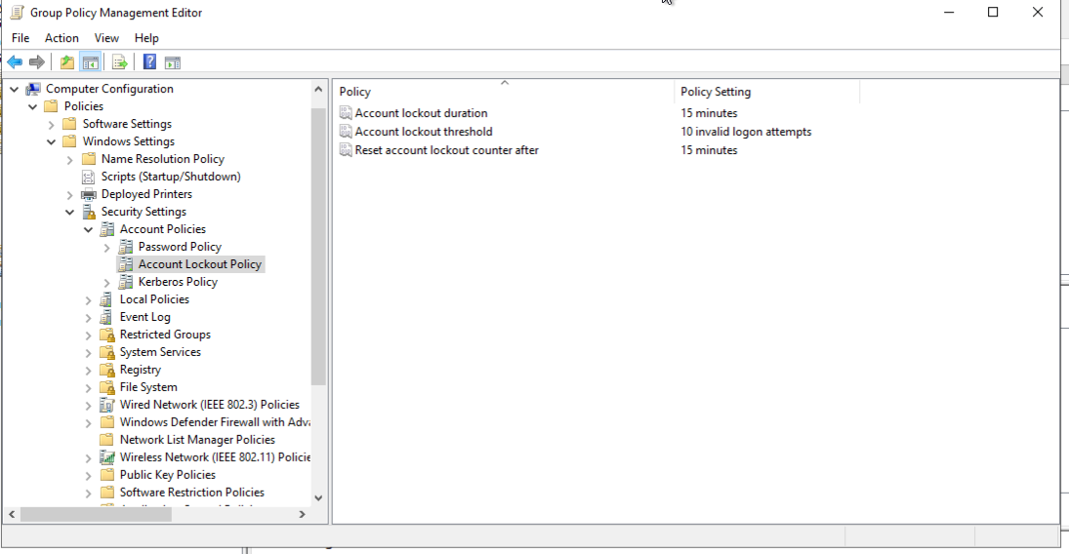

**Task #3:** Create a GPO: Enabling Verbose PowerShell Logging and Transcription

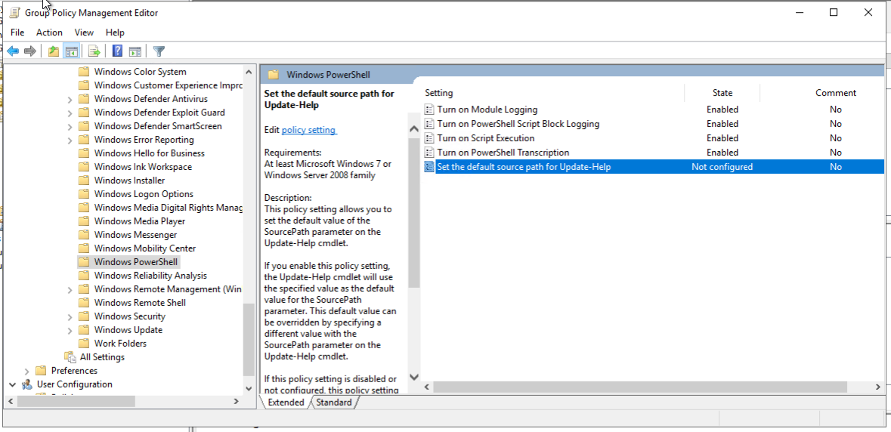

**Task #4:** Create a Script: Enumerate Access Control Lists

